**Setting Up Development Environment**

Setting Up Your Developer Environment

**Select Your Operating System** (OS): Choose an operating system that best suits your preferences and project requirements.

I installed and used windows 10 as it is compatible with my Pc, has a friendly interface and I am familiar with it.

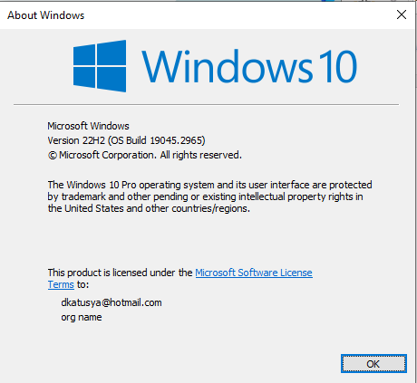

I rufus(ed) my flash disk (8 GB) and configured a windows 10 setup.

I booted my machine with the flash installed and ran the setup

Once the setup is complete I set up the required items like keyboard, region, user and created a password.

Once completed I had successfully installed windows 10 on my laptop.

I added a few extra files to make my pc look interesting like font and display.

**Install a Text Editor or Integrated Development Environment (IDE):** Select and install a text editor or IDE suitable for your programming languages and workflow. Download and Install Visual Studio Code.

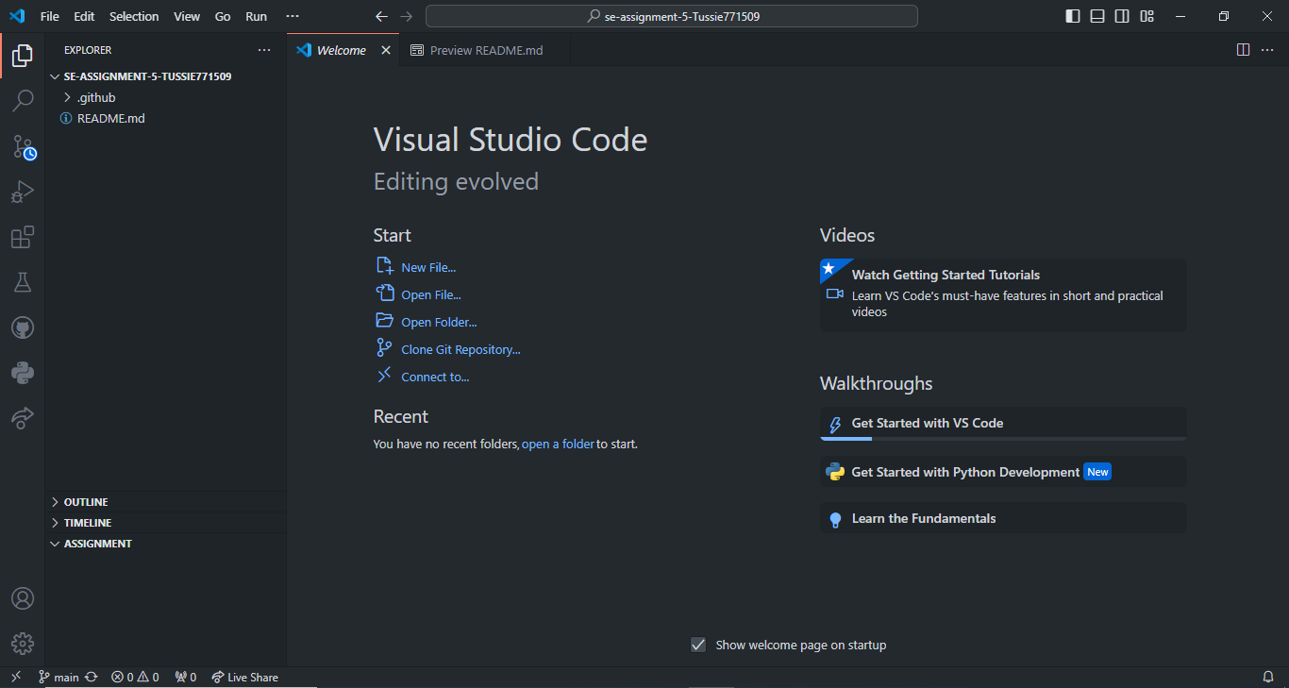

I went to the site <https://code.visualstudio.com/Download> and downloaded the setup for latest version of VS Code.

Once the setup was downloaded, I ran it and it unpacked and installed Visual studio code.

I downloaded some plugins and a few extra extensions to enable me run my work smoothly.

Some of the extensions installed include flutter, python, live server, prettier and GitHub color editor extension.

**Set Up Version Control System**: Install Git and configure it on your local machine. Create a GitHub account for hosting your repositories.

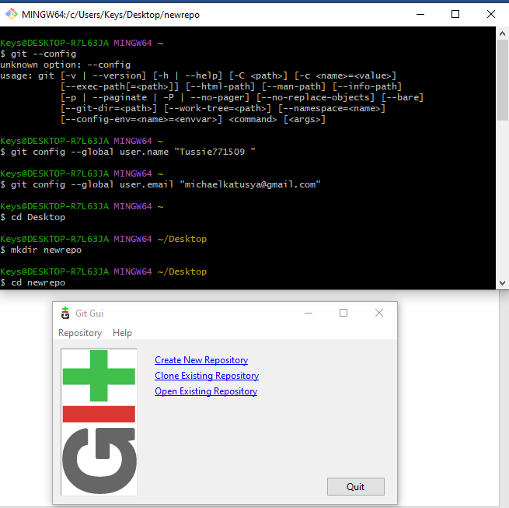

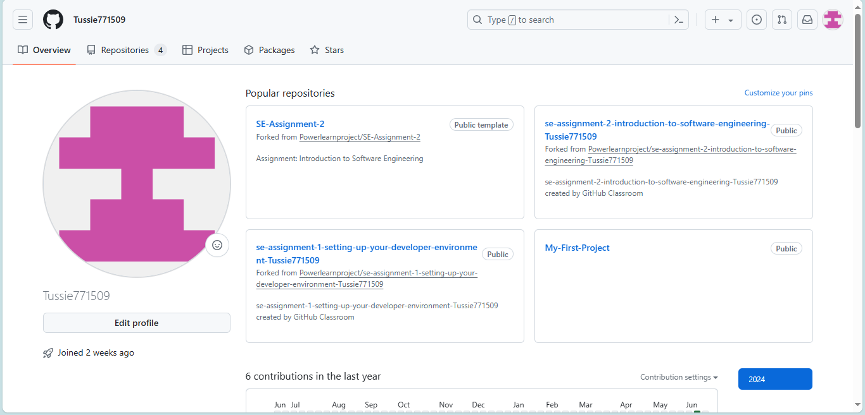

Install Necessary Programming Languages and Runtimes

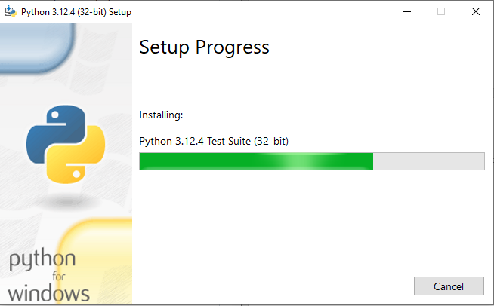

Configure a Database (MySQL)

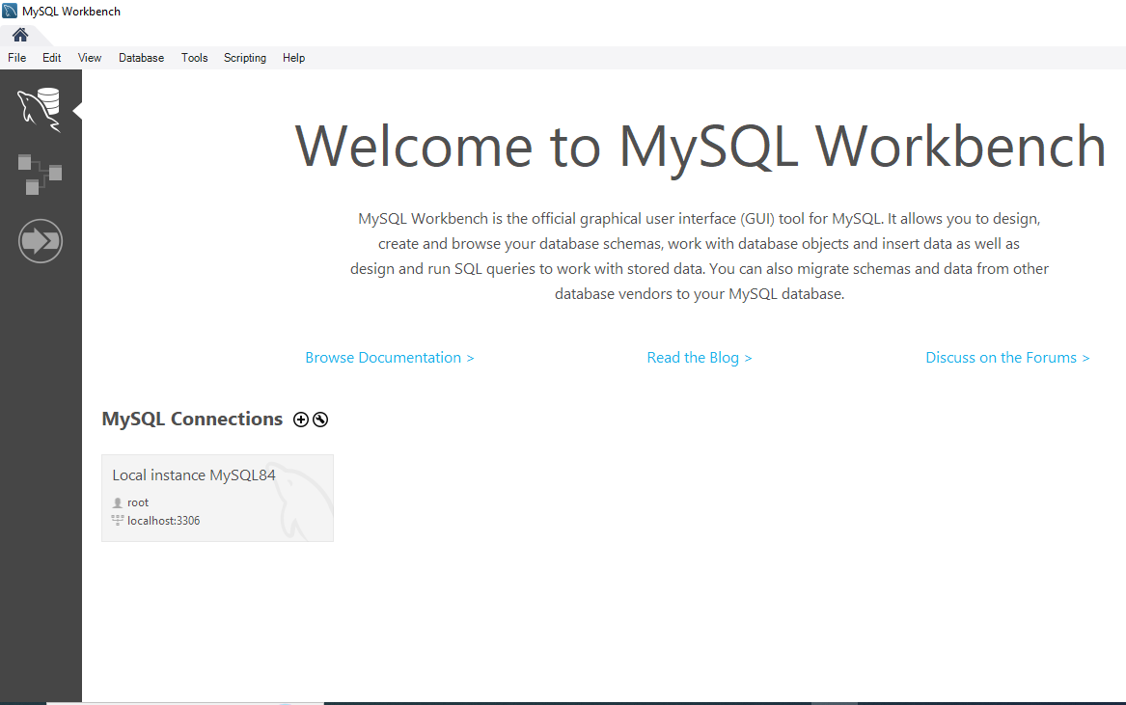

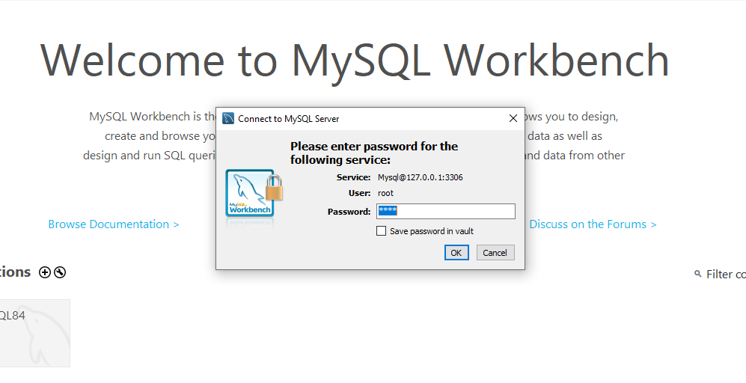

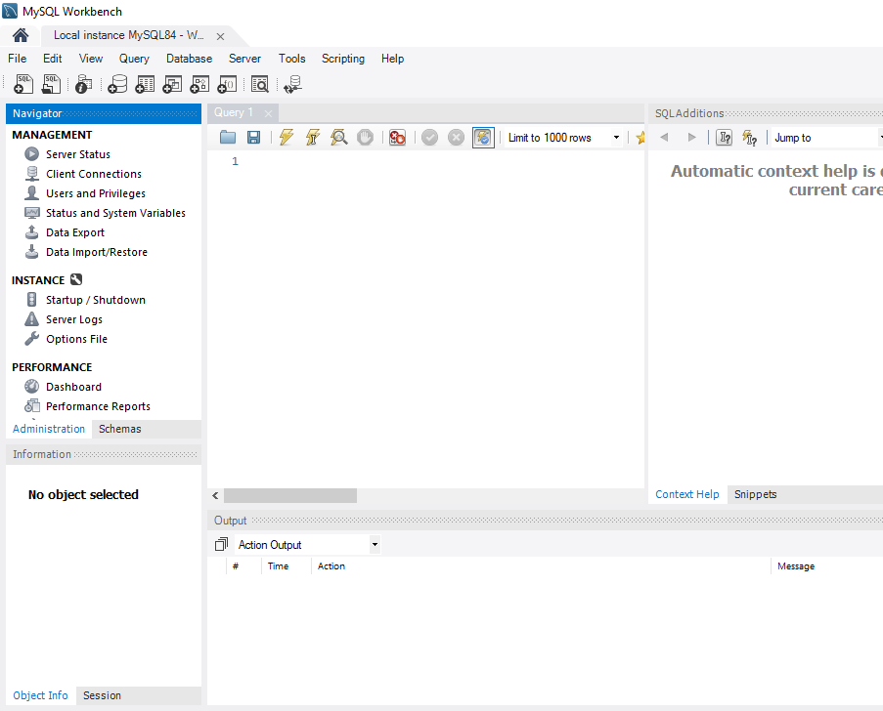

**Explore Extensions and Plugins**: Explore available extensions, plugins, and add-ons for your chosen text editor or IDE to enhance functionality, such as syntax highlighting, linting, code formatting, and version control integration.